

**HERITAGE INSTITUTE OF**

**TECHNOLOGY**

**Paper Name -** Computer Organisation and Architechture

**Paper Code -** CSE2252

**Team Members -** Chinki Raj - 2361021

Vivek Kumar - 2361023

Asmita Banerjee - 2361024

Kishalay Kamar - 2361025

Aritra Hutait - 2361026

Table of Contents

AND GATE (Dataflow & Behavioral Model) 2

OR GATE (Dataflow & Behavioral Model)8

NOT GATE (Dataflow & Behavioral Model) 14

NAND GATE (Dataflow & Behavioral Model) 19

NOR GATE (Dataflow & Behavioral Model) 25

XOR GATE (Dataflow & Behavioral Model) 31

XNOR GATE (Dataflow & Behavioral Model)37

AND GATE using NAND GATE 43

OR GATE using NAND GATE 46

NOT GATE using NAND GATE 49

XOR GATE using NAND GATE 51

XNOR GATE using NAND GATE 54

AND GATE using NOR GATE 57

OR GATE using NOR GATE 60

NOT GATE using NOR GATE 63

XOR GATE using NOR GATE 65

XNOR GATE using NOR GATE 68

HALF ADDER (Dataflow, Behavioral & Structural Model) 71

FULL ADDER (Dataflow, Behavioral & Structural Model) 80

2:1 MUX (Dataflow & Behavioral Model) 91

4:1 MUX (Dataflow & Behavioral Model) 97

3:8 DECODER (Dataflow & Behavioral Model) 103

# AND Gate Dataflow Model

**VHD Code:**

entity AND_DF is

Port ( A : in STD_LOGIC;

1. : in STD_LOGIC;
2. : out STD_LOGIC); end AND_DF; architecture Dataflow of AND_DF is begin

C <= A AND B;

end Dataflow;

## RTL Diagram

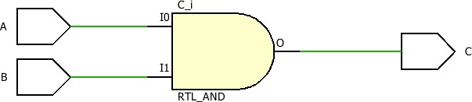

**TBW Code:**

entity AND_DF_TBW is

-- Port ( );

end AND_DF_TBW;

architecture Dataflow of AND_DF_TBW is component AND_DF is

Port ( A : in STD_LOGIC; B : in STD_LOGIC;

C : out STD_LOGIC); end component;

Signal a1:STD_LOGIC:='0';

Signal b1:STD_LOGIC:='0';

Signal c1:STD_LOGIC;

begin

UUT: AND_DF Port map(A=>a1, B=>b1, c=>c1);

stim_proc: process

begin

wait for 100ns;

a1<='0'; b1<='0'; wait for 100ns; a1<='0';

b1<='1';

wait for 100ns;

a1<='1';

b1<='0';

wait for 100ns;

a1<='1';

b1<='1';

wait; end process; end Dataflow;

## TBW Waveform

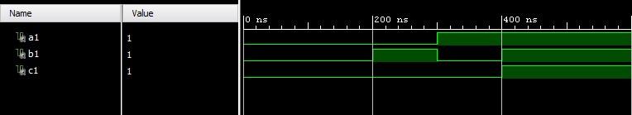

# AND Gate Behavioral Model

**VHD Code:**

entity AND_GATE_BV is

Port ( A : in STD_LOGIC;

1. : in STD_LOGIC;
2. : out STD_LOGIC);

end AND_GATE_BV;

architecture Behavioral of AND_GATE_BV is

begin process(A,B) begin if(A='1' and B='1') then c<='1'; else c<='0'; end if; end process;

end Behavioral;

## RTL Diagram



**TBW Code:**

entity AND_GATE_TBW is

-- Port ( );

end AND_GATE_TBW;

architecture Behavioral of AND_GATE_TBW is component AND_GATE_BV is

Port ( A : in STD_LOGIC;

1. : in STD_LOGIC;
2. : out STD_LOGIC); end component;

Signal a1:STD_LOGIC:='0';

Signal b1:STD_LOGIC:='0';

Signal c1:STD_LOGIC;

begin

UUT: AND_GATE_BV Port map(A=>a1, B=>b1, C=>c1); stim_proc: process begin wait for 100ns; a1<='0'; b1<='0'; wait for 100ns; a1<='0'; b1<='1'; wait for 100ns; a1<='1'; b1<='0'; wait for 100ns; a1<='1'; b1<='1'; wait; end process; end Behavioral;

## TBW Waveform



# OR Gate Dataflow Model

**VHD Code:**

entity OR_DF is

Port ( a : in STD_LOGIC; b : in STD_LOGIC; c : out STD_LOGIC); end OR_DF; architecture Dataflow of OR_DF is begin c <= a OR b; end Dataflow;

## RTL Diagram

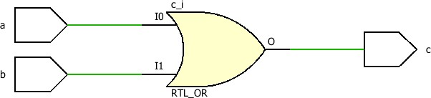

**TBW Code:**

entity OR_DF_TBW is

-- Port ( );

end OR_DF_TBW;

architecture Dataflow of OR_DF_TBW is component OR_DF is

Port ( a : in STD_LOGIC; b : in STD_LOGIC; c : out STD_LOGIC); end component;

Signal a1:STD_LOGIC:='0';

Signal b1:STD_LOGIC:='0';

Signal c1:STD_LOGIC;

begin

UUT: OR_DF Port map(a=>a1, b=>b1, c=>c1); stim_proc: process

begin

wait for 100ns;

a1<='0'; b1<='0'; wait for 100ns; a1<='0';

b1<='1';

wait for 100ns;

a1<='1';

b1<='0';

wait for 100ns;

a1<='1';

b1<='1';

wait; end process; end Dataflow;

## TBW Waveform

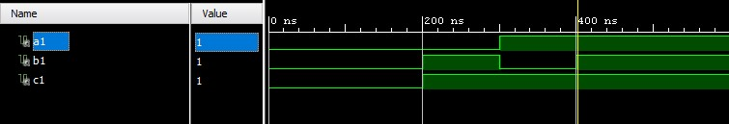

# OR Gate Behavioral Model

**VHD Code:**

entity OR_GATE_BV is

Port ( A : in STD_LOGIC;

1. : in STD_LOGIC;
2. : out STD_LOGIC); end OR_GATE_BV; architecture Behavioral of OR_GATE_BV is begin process(A,B) begin if(A='0' and B='0') then c<='0'; else c<='1'; end if; end process; end Behavioral;

## RTL Diagram

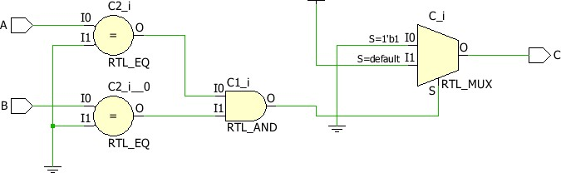

**TBW Code:**

entity OR_GATE_TBW is

-- Port ( );

end OR_GATE_TBW; architecture Behavioral of OR_GATE_TBW is component OR_GATE_BV is

Port ( a : in STD_LOGIC; b : in STD_LOGIC; c : out STD_LOGIC); end component;

Signal a1:STD_LOGIC:='0';

Signal b1:STD_LOGIC:='0'; Signal c1:STD_LOGIC; begin

UUT: OR_GATE_BV Port map(a=>a1, b=>b1, c=>c1); stim_proc: process begin wait for 100ns; a1<='0'; b1<='0'; wait for 100ns; a1<='0'; b1<='1'; wait for 100ns; a1<='1'; b1<='0'; wait for 100ns; a1<='1'; b1<='1'; wait; end process; end Behavioral;

## TBW Waveform



# NOT Gate Dataflow Model



**VHD Code:**



entity NOT_DF is

Port ( a : in STD_LOGIC; b : out STD_LOGIC); end NOT_DF; architecture Dataflow of NOT_DF is begin b <= NOT a;

end Dataflow;

**RTL Diagram**



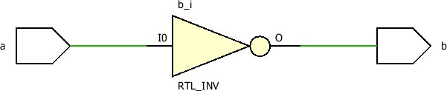



**TBW Code:**



entity NOT_DF_TBW is

-- Port ( );

end NOT_DF_TBW; architecture Dataflow of NOT_DF_TBW is component NOT_DF is

Port ( a : in STD_LOGIC; b : out STD_LOGIC); end component;

Signal a1:STD_LOGIC:='0'; Signal b1:STD_LOGIC; begin

UUT: NOT_DF Port map(a=>a1, b=>b1); stim_proc: process begin wait for 100ns; a1<='0'; wait for 100ns; a1<='1'; wait; end process; end Dataflow;

## TBW Waveform

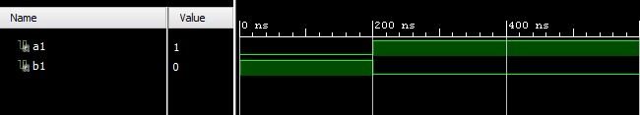

## NOT Gate Behavioral Model

**VHD Code:**

entity NOT_GATE_BV is

Port ( A : in

STD_LOGIC;

B : out STD_LOGIC); end NOT_GATE_BV; architecture Behavioral of NOT_GATE_BV is begin process(A) begin if(A='0') then

B<='1'; else

B<='0'; end if; end process; end Behavioral;

### RTL Diagram

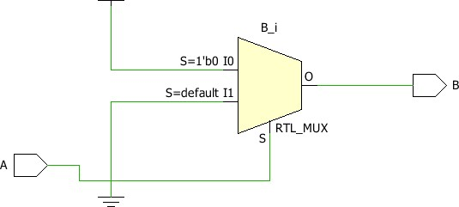

**TBW Code:**

entity NOT_GATE_TBW is

-- Port ( );

end NOT_GATE_TBW; architecture Behavioral of NOT_GATE_TBW is component NOT_GATE_BV is

Port ( a : in STD_LOGIC; b : out STD_LOGIC); end component;

Signal a1:STD_LOGIC:='0';

Signal b1:STD_LOGIC;

begin

UUT: NOT_GATE_BV Port map(a=>a1, b=>b1); stim_proc: process begin wait for 100ns; a1<='0'; wait for 100ns; a1<='1'; wait; end process; end Behavioral;

### TBW Waveform



# NAND Gate Dataflow Model



**VHD Code:**



entity NAND_DF is

Port ( a : in STD_LOGIC; b : in STD_LOGIC; c : out STD_LOGIC); end NAND_DF; architecture Dataflow of NAND_DF is begin c<=a NAND b; end Dataflow;

**RTL Diagram**

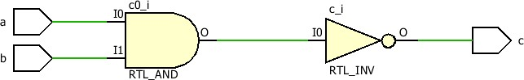

**TBW Code:**



entity NAND_DF_TBW is

-- Port ( );

end NAND_DF_TBW;

architecture Dataflow of NAND_DF_TBW is component NAND_DF is

Port ( a : in STD_LOGIC; b : in STD_LOGIC; c : out STD_LOGIC); end component;

Signal a1:STD_LOGIC:='0';

Signal b1:STD_LOGIC:='0'; Signal c1:STD_LOGIC; begin

UUT: NAND_DF Port map(a=>a1, b=>b1, c=>c1); stim_proc: process begin wait for 100ns; a1<='0'; b1<='0'; wait for 100ns; a1<='0'; b1<='1'; wait for 100ns; a1<='1'; b1<='0'; wait for 100ns; a1<='1'; b1<='1'; wait;

end process; end Dataflow;

## TBW Waveform

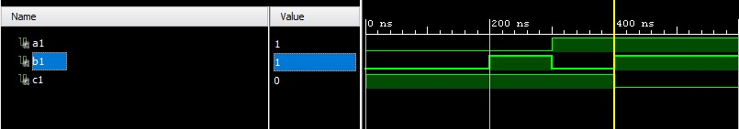

## NAND Gate Behavioral Model

**VHD Code:**

entity NAND_GATE_BV is

Port ( A : in STD_LOGIC;

1. : in STD_LOGIC;
2. : out STD_LOGIC); end NAND_GATE_BV; architecture Behavioral of NAND_GATE_BV is begin process(A,B) begin if(A='1' and B='1') then c<='0'; else c<='1'; end if; end process;

end Behavioral;

### RTL Diagram

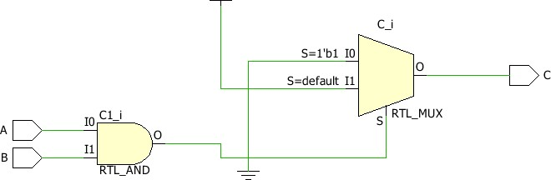

**TBW Code:**

entity NAND_GATE_TBW is

-- Port ( );

end NAND_GATE_TBW; architecture Dataflow of NAND_GATE_TBW is component NAND_GATE_BV is

Port ( a : in STD_LOGIC; b : in STD_LOGIC; c : out STD_LOGIC); end component;

Signal a1:STD_LOGIC:='0';

Signal b1:STD_LOGIC:='0'; Signal c1:STD_LOGIC; begin

UUT: NAND_GATE_BV Port map(a=>a1, b=>b1, c=>c1); stim_proc: process begin

wait for 100ns; a1<='0'; b1<='0'; wait for 100ns; a1<='0'; b1<='1'; wait for 100ns; a1<='1'; b1<='0'; wait for 100ns; a1<='1'; b1<='1'; wait; end process; end Dataflow;

### TBW Waveform



## NOR Gate Dataflow Model

**VHD Code:**

entity NOR_DF is

Port ( a : in STD_LOGIC; b : in STD_LOGIC; c : out STD_LOGIC); end NOR_DF;

architecture Dataflow of NOR_DF is

begin

c<=a NOR b;

end Dataflow;

### RTL Diagram

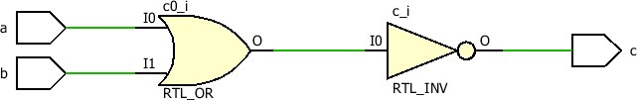

**TBW Code:**

entity NOR_DF_TBW is

-- Port ( );

end NOR_DF_TBW;

architecture Dataflow of NOR_DF_TBW is component NOR_DF is

Port ( a : in STD_LOGIC; b : in STD_LOGIC; c : out STD_LOGIC); end component;

Signal a1:STD_LOGIC:='0';

Signal b1:STD_LOGIC:='0';

Signal c1:STD_LOGIC;

begin

UUT: NOR_DF Port map(a=>a1, b=>b1, c=>c1); stim_proc: process begin wait for 100ns; a1<='0'; b1<='0';

wait for 100ns;

a1<='0'; b1<='1';

wait for 100ns;

a1<='1'; b1<='0'; wait for 100ns;

a1<='1';

b1<='1';

wait; end process; end Dataflow;

### TBW Waveform

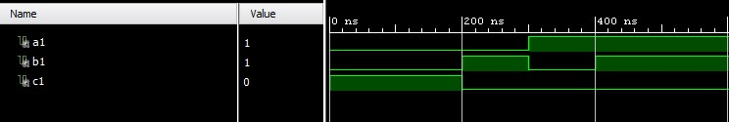

## NOR Gate Behavioral Model

**VHD Code:**

entity NOR_GATE_BV is

Port ( A : in

STD_LOGIC;

1. : in STD_LOGIC;
2. : out STD_LOGIC); end NOR_GATE_BV; architecture Behavioral of NOR_GATE_BV is begin process(A,B) begin if(A='0' and B='0') then

C<='1'; else

C<='0'; end if; end process;

end Behavioral;

### RTL Diagram

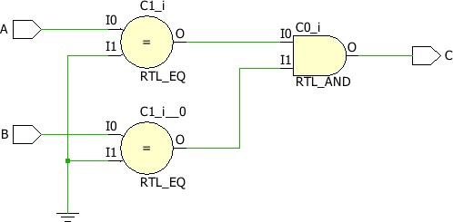

**TBW Code:**

entity NOR_GATE_TBW is

-- Port ( );

end NOR_GATE_TBW; architecture Behavioral of NOR_GATE_TBW is component NOR_GATE_BV is

Port ( A : in STD_LOGIC; B : in STD_LOGIC;

C : out STD_LOGIC); end component;

Signal a1:STD_LOGIC:='0'; Signal b1:STD_LOGIC:='0'; Signal c1:STD_LOGIC; begin

UUT: NOR_GATE_BV Port map(A=>a1, B=>b1, C=>c1); stim_proc: process

begin wait for 100ns; a1<='0'; b1<='0'; wait for 100ns; a1<='0'; b1<='1'; wait for 100ns; a1<='1'; b1<='0'; wait for 100ns; a1<='1'; b1<='1'; wait; end process; end Behavioral;

### TBW Waveform



## XOR Gate Dataflow Model

**VHD Code:**

entity XOR_DF is

Port ( a : in STD_LOGIC; b : in STD_LOGIC; c : out STD_LOGIC); end XOR_DF;

architecture Dataflow of XOR_DF is

begin

c<=a XOR b;

end Dataflow;

### RTL Diagram

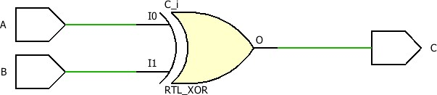

**TBW Code:**

entity XOR_DF_TBW is

-- Port ( );

end XOR_DF_TBW;

architecture Dataflow of XOR_DF_TBW is component XOR_DF is

Port ( a : in STD_LOGIC; b : in STD_LOGIC; c : out STD_LOGIC); end component;

Signal a1:STD_LOGIC:='0';

Signal b1:STD_LOGIC:='0';

Signal c1:STD_LOGIC;

begin

UUT: XOR_DF Port map(a=>a1, b=>b1, c=>c1); stim_proc: process begin wait for 100ns; a1<='0'; b1<='0';

wait for 100ns;

a1<='0'; b1<='1'; wait for 100ns;

a1<='1'; b1<='0';

wait for 100ns;

a1<='1';

b1<='1';

wait; end process; end Dataflow;

### TBW Waveform

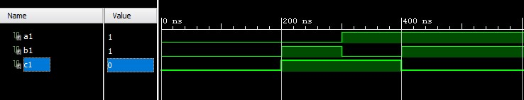

## XOR Gate Behavioral Model

**VHD Code:**

entity XOR_GATE_BV is

Port ( A : in

STD_LOGIC;

1. : in STD_LOGIC;
2. : out STD_LOGIC); end XOR_GATE_BV; architecture Behavioral of XOR_GATE_BV is begin process(A,B) begin if(A=B) then

C<='0'; else

C<='1'; end if; end process;

end Behavioral;

### RTL Diagram

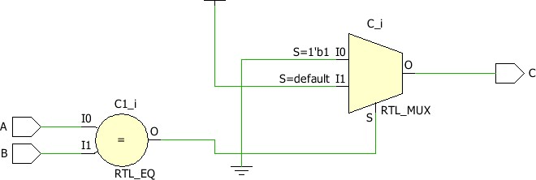

**TBW Code:**

entity XOR_GATE_TBW is

-- Port ( );

end XOR_GATE_TBW; architecture Behavioral of XOR_GATE_TBW is component XOR_GATE_BV is

Port ( A : in STD_LOGIC;

B: in STD_LOGIC;

C : out STD_LOGIC); end component;

Signal a1:STD_LOGIC:='0'; Signal b1:STD_LOGIC:='0';

Signal c1:STD_LOGIC;

begin

UUT: XOR_GATE_BV Port map(A=>a1, B=>b1, C=>c1); stim_proc: process

begin wait for 100ns; a1<='0'; b1<='0'; wait for 100ns; a1<='0'; b1<='1'; wait for 100ns; a1<='1'; b1<='0'; wait for 100ns; a1<='1'; b1<='1'; wait; end process; end Behavioral;

### TBW Waveform



## XNOR Gate Dataflow Model

**VHD Code:**

entity XNOR_DF is

Port ( a : in STD_LOGIC; b : in STD_LOGIC; c : out STD_LOGIC); end XNOR_DF;

architecture Dataflow of XNOR_DF is

begin

c<=a XNOR b;

end Dataflow;

### RTL Diagram

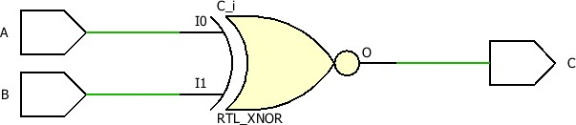

**TBW Code:**

entity XNOR_DF_TBW is

-- Port ( );

end XNOR_DF_TBW; architecture Dataflow of XNOR_DF_TBW is component XNOR_DF is

Port ( a : in STD_LOGIC; b : in STD_LOGIC; c : out STD_LOGIC); end component;

Signal a1:STD_LOGIC:='0';

Signal b1:STD_LOGIC:='0'; Signal c1:STD_LOGIC; begin

UUT: XNOR_DF Port map(a=>a1, b=>b1, c=>c1); stim_proc: process begin wait for 100ns; a1<='0'; b1<='0'; wait for 100ns; a1<='0'; b1<='1';

wait for 100ns;

a1<='1'; b1<='0'; wait for 100ns; a1<='1'; b1<='1'; wait; end process; end Dataflow;

### TBW Waveform

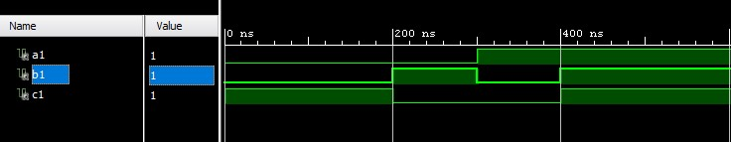

## XNOR Gate Behavioral Model

**VHD Code:**

entity XNOR_GATE_BV is

Port ( A : in STD_LOGIC;

1. : in STD_LOGIC;
2. : out STD_LOGIC); end XOR_GATE_BV; architecture Behavioral of XNOR_GATE_BV is begin process(A,B) begin if(A=B) then

C<='1'; else

C<='0'; end if; end process;

end Behavioral;

### RTL Diagram

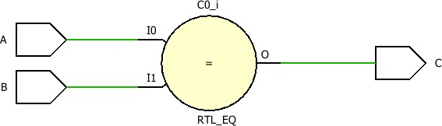

**TBW Code:**

entity XNOR_GATE_TBW is

-- Port ( );

end XNOR_GATE_TBW;

architecture Behavioral of XNOR_GATE_TBW is component XNOR_GATE_BV is

Port ( A : in STD_LOGIC; B : in STD_LOGIC;

C : out STD_LOGIC); end component;

Signal a1:STD_LOGIC:='0'; Signal b1:STD_LOGIC:='0'; Signal c1:STD_LOGIC; begin

UUT: XNOR_GATE_BV Port map(A=>a1, B=>b1, C=>c1); stim_proc: process

begin wait for 100ns; a1<='0'; b1<='0'; wait for 100ns; a1<='0'; b1<='1'; wait for 100ns; a1<='1'; b1<='0'; wait for 100ns; a1<='1'; b1<='1'; wait; end process; end Behavioral;

### TBW Waveform



## AND_NAND Gate Dataflow Model

**VHD Code:**

entity AND_NAND_DF is

Port ( A : in

STD_LOGIC;

1. : in STD_LOGIC;
2. : out STD_LOGIC); end AND_NAND_DF; architecture Dataflow of AND_NAND_DF is begin

C<=(A NAND B) NAND (A NAND B);

end Dataflow;

### RTL Diagram

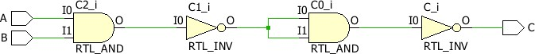

**TBW Code:**

entity AND_NAND_TBW is

-- Port ( );

end AND_NAND_TBW; architecture Dataflow of AND_NAND_TBW is component NAND_DF is

Port ( A : in STD_LOGIC;

1. : in STD_LOGIC;
2. : out STD_LOGIC); end component;

Signal a1:STD_LOGIC:='0';

Signal b1:STD_LOGIC:='0'; Signal c1:STD_LOGIC; begin

UUT: AND_NAND_DF Port map(A=>a1, B=>b1, C=>c1); stim_proc: process begin wait for 100ns; a1<='0'; b1<='0'; wait for 100ns; a1<='0'; b1<='1'; wait for 100ns; a1<='1'; b1<='0'; wait for 100ns; a1<='1'; b1<='1'; wait; end process; end Dataflow;

### TBW Waveform

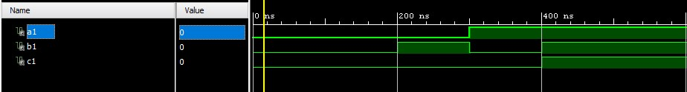

## OR_NAND Gate Dataflow Model

**VHD Code:**

entity OR_NAND_DF is

Port ( A : in STD_LOGIC; B : in STD_LOGIC;

C : out STD_LOGIC); end OR_NAND_DF; architecture Dataflow of OR_NAND_DF is begin

C<=((A NAND A) NAND (B NAND B));

end Dataflow;

### RTL Diagram

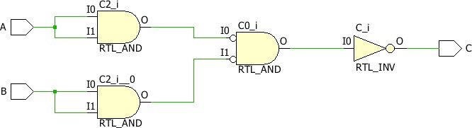

**TBW Code:**

entity AND_NAND_TBW is

-- Port ( );

end AND_NAND_TBW; architecture Dataflow of AND_NAND_TBW is component NAND_DF is

Port ( A : in

STD_LOGIC;

1. : in STD_LOGIC;
2. : out STD_LOGIC); end component;

Signal a1:STD_LOGIC:='0'; Signal b1:STD_LOGIC:='0'; Signal c1:STD_LOGIC; begin

UUT: AND_NAND_DF Port map(A=>a1, B=>b1, C=>c1); stim_proc: process begin wait for 100ns; a1<='0'; b1<='0'; wait for 100ns; a1<='0'; b1<='1'; wait for 100ns; a1<='1'; b1<='0'; wait for 100ns; a1<='1'; b1<='1'; wait; end process;

end Dataflow;

### TBW Waveform

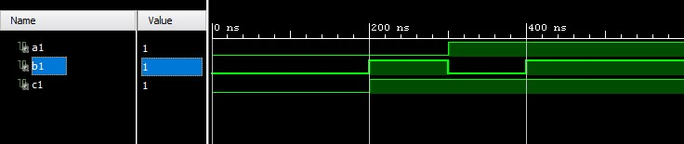

## NOT_NAND Gate Dataflow Model

**VHD Code:**

entity NOT_NAND_DF is

Port ( A : in

STD_LOGIC;

B : out STD_LOGIC);

end NOT_NAND_DF; architecture Dataflow of NOT_NAND_DF is begin

B<=(A NAND A);

end Dataflow;

### RTL Diagram

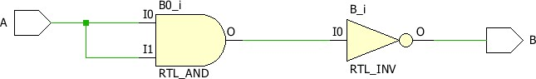

**TBW Code:**

entity NOT_NAND_TBW is

-- Port ( );

end NOT_NAND_TBW; architecture Dataflow of NOT_NAND_TBW is component NOT_NAND_DF is

Port ( A : in STD_LOGIC;

B : out STD_LOGIC); end component;

Signal a1:STD_LOGIC:='0'; Signal b1:STD_LOGIC; begin

UUT: NOT_NAND_DF Port map(A=>a1, B=>b1); stim_proc: process begin wait for 100ns; a1<='0'; wait for 100ns; a1<='1'; wait; end process; end Dataflow;

### TBW Waveform

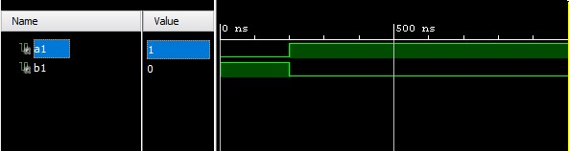

## XOR_NAND Gate Dataflow Model

**VHD Code:**

entity XOR_NAND_DF is

Port ( A : in

STD_LOGIC;

1. : in STD_LOGIC;
2. : out STD_LOGIC);

end XOR_NAND_DF;

architecture Dataflow of XOR_NAND_DF is

begin

C<=((A NAND A) NAND B) NAND (A NAND (B NAND B));

end Dataflow;

### RTL Diagram

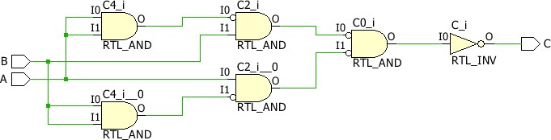

**TBW Code:**

entity XOR_NAND_TBW is

-- Port ( );

end XOR_NAND_TBW; architecture Dataflow of XOR_NAND_TBW is component XOR_NAND_DF is

Port ( A : in STD_LOGIC;

1. : in STD_LOGIC;
2. : out STD_LOGIC); end component;

Signal a1:STD_LOGIC:='0';

Signal b1:STD_LOGIC:='0'; Signal c1:STD_LOGIC; begin

UUT: XOR_NAND_DF Port map(A=>a1, B=>b1, C=>c1); stim_proc: process begin wait for 100ns; a1<='0'; b1<='0';

wait for 100ns;

a1<='0';

b1<='1';

wait for 100ns;

a1<='1';

b1<='0';

wait for 100ns; a1<='1'; b1<='1';

wait; end process; end Dataflow;

### TBW Waveform

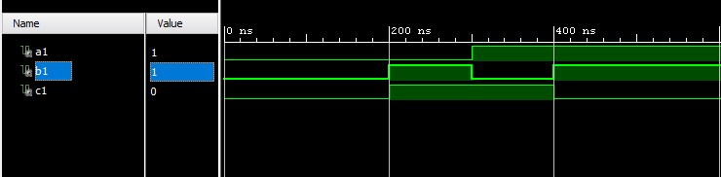

## XNOR_NAND Gate Dataflow Model

**VHD Code:**

entity XNOR_NAND_DF is

Port ( A : in STD_LOGIC;

1. : in STD_LOGIC;
2. : out STD_LOGIC);

end XNOR_NAND_DF;

architecture Dataflow of XNOR_NAND_DF is

begin

C<=((A NAND A) NAND B) NAND (A NAND (B NAND B)) NAND ((A NAND A) NAND B) NAND (A NAND (B NAND B));

end Dataflow;

### RTL Diagram

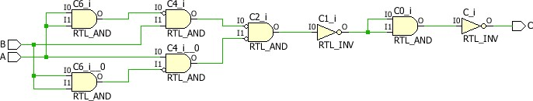

**TBW Code:**

entity XNOR_NAND_TBW is

-- Port ( );

end XNOR_NAND_TBW; architecture Dataflow of XNOR_NAND_TBW is component XNOR_NAND_DF is

Port ( A : in

STD_LOGIC; B : in

STD_LOGIC;

C : out STD_LOGIC); end component;

Signal a1:STD_LOGIC:='0';

Signal b1:STD_LOGIC:='0'; Signal c1:STD_LOGIC; begin

UUT: XNOR_NAND_DF Port map(A=>a1, B=>b1, C=>c1); stim_proc: process begin wait for 100ns; a1<='0'; b1<='0';

wait for 100ns;

a1<='0';

b1<='1';

wait for 100ns;

a1<='1';

b1<='0';

wait for 100ns; a1<='1'; b1<='1'; wai

**AND_NOR Gate Dataflow Model VHD Code:**

entity AND_NOR_DF is

Port ( A : in STD_LOGIC;

1. : in STD_LOGIC;
2. : out STD_LOGIC);

end AND_NOR_DF; architecture Dataflow of AND_NOR_DF is

begin

C<=((A NOR A) NOR (B NOR B)); end Dataflow;

### RTL Diagram

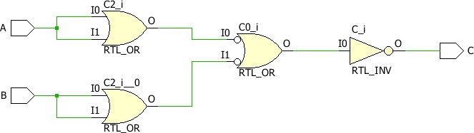

**TBW Code:**

entity AND_NOR_TBW is

-- Port ( );

end AND_NOR_TBW; architecture Dataflow of AND_NOR_TBW is component AND_NOR_DF is

Port ( A : in STD_LOGIC;

1. : in STD_LOGIC;
2. : out STD_LOGIC); end component;

Signal a1:STD_LOGIC:='0'

Signal b1:STD_LOGIC:='0'; Signal c1:STD_LOGIC; begin

UUT: AND_NOR_DF Port map(A=>a1, B=>b1, C=>c1); stim_proc: process begin wait for 100ns; a1<='0'; b1<='0';

wait for 100ns;

a1<='0';

b1<='1';

wait for 100ns;

a1<='1';

b1<='0';

wait for 100ns; a1<='1'; b1<='1'; wait; end process; end Dataflow;

### TBW Waveform

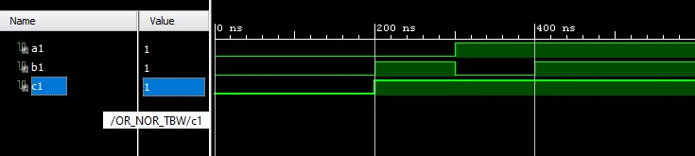

# OR_NOR Gate Dataflow Model

**VHD Code:**

entity OR_NOR_GATE_DF is

Port ( A : in STD_LOGIC; B : in STD_LOGIC;

C : out STD_LOGIC);

end OR_NOR_GATE_DF;

architecture Dataflow of OR_NOR_GATE_DF is

begin

C<=(A NOR B) NOR (A NOR B);

end Dataflow;

## RTL Diagram

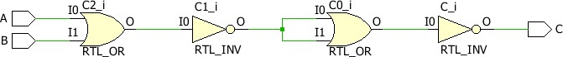

**TBW Code:**

entity OR_NOR_TBW is

-- Port ( );

end OR_NOR_TBW; architecture Dataflow of OR_NOR_TBW is component OR_NOR_GATE_DF is

Port ( A : in STD_LOGIC; B : in STD_LOGIC;

C : out STD_LOGIC); end component;

Signal a1:STD_LOGIC:='0';

Signal b1:STD_LOGIC:='0';

Signal c1:STD_LOGIC; begin

UUT: OR_NOR_GATE_DF Port map(A=>a1, B=>b1, C=>c1); stim_proc: process begin wait for 100ns; a1<='0'; b1<='0';

wait for 100ns;

a1<='0';

b1<='1';

wait for 100ns;

a1<='1';

b1<='0';

wait for 100ns; a1<='1'; b1<='1'; wait; end process; end Dataflow;

## TBW Waveform



# NOT_NOR Gate Dataflow Model

**VHD Code:**

entity NOT_NOR _DF is

Port ( A : in STD_LOGIC;

B : out STD_LOGIC); end NOT_NOR _DF; architecture Dataflow of NOT_NOR_DF is begin

B<=(A NOR A); end Dataflow;

## RTL Diagram

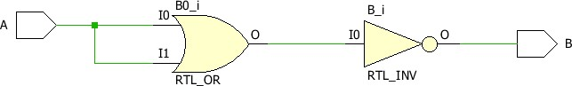

**TBW Code:**

entity NOT_NOR_TBW is

-- Port ( );

end NOT_NOR_TBW; architecture Dataflow of NOT_NOR_TBW is component NOT_NOR_DF is

Port ( A : in STD_LOGIC;

B : out STD_LOGIC); end component;

Signal a1:STD_LOGIC:='0'; Signal b1:STD_LOGIC; begin

UUT: NOT_NOR_DF Port map(A=>a1, B=>b1); stim_proc: process begin wait for 100ns;

a1<='0'; wait for 100ns; a1<='1'; wait; end process; end Dataflow;

## TBW Waveform

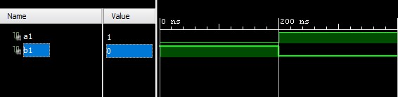

## XOR_NOR Gate Dataflow Model

**VHD Code:**

entity XOR_NOR_GATE_DF is

Port ( A : in STD_LOGIC;

1. : in STD_LOGIC;
2. : out STD_LOGIC);

end XOR_NOR_GATE _DF;

architecture Dataflow of XOR_NOR _GATE_DF is

begin

C<=((A NOR A) NOR B) NOR (A NOR (B NOR B)) NOR ((A NOR A) NOR B) NOR (A NOR

(B NOR B));

end Dataflow;

### RTL Diagram

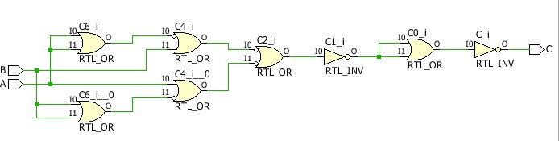

**TBW Code:**

entity XOR_NOR_TBW is

-- Port ( );

end XOR_NOR _TBW; architecture Dataflow of XOR_NOR _TBW is component XOR_NOR_GATE _DF is

Port ( A : in STD_LOGIC; B : in STD_LOGIC;

C : out STD_LOGIC); end component;

Signal a1:STD_LOGIC:='0';

Signal b1:STD_LOGIC:='0';

Signal c1:STD_LOGIC; begin

UUT: XOR_NOR_GATE _DF Port map(A=>a1, B=>b1, C=>c1); stim_proc: process begin wait for 100ns; a1<='0'; b1<='0';

wait for 100ns;

a1<='0';

b1<='1';

wait for 100ns;

a1<='1';

b1<='0';

wait for 100ns; a1<='1'; b1<='1'; wait; end process; end Dataflow;

### TBW Waveform

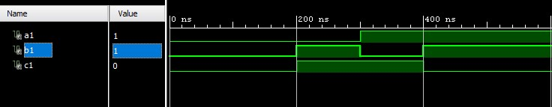

# XNOR_NOR Gate Dataflow Model

**VHD Code:**

entity XNOR_NOR_DF is

Port ( A : in STD_LOGIC;

1. : in STD_LOGIC;
2. : out STD_LOGIC); end XNOR_NOR_DF; architecture Dataflow of XNOR_NOR_DF is begin

C<=((A NOR A) NOR B) NOR (A NOR (B NOR B));

end Dataflow;

## RTL Diagram

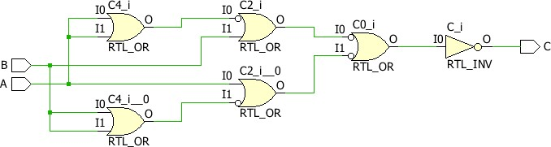

**TBW Code:**

entity XNOR_NOR_TBW is

-- Port ( );

end XNOR_NOR_TBW; architecture Dataflow of XNOR_NOR_TBW is component XNOR_NOR_DF is

Port ( A : in STD_LOGIC; B : in STD_LOGIC;

C : out STD_LOGIC); end component;

Signal a1:STD_LOGIC:='0';

Signal b1:STD_LOGIC:='0'; Signal c1:STD_LOGIC; begin

UUT: XNOR_NOR_DF Port map(A=>a1, B=>b1, C=>c1); stim_proc: process begin wait for 100ns; a1<='0'; b1<='0'; wait for 100ns; a1<='0'; b1<='1'; wait for 100ns; a1<='1'; b1<='0'; wait for 100ns; a1<='1'; b1<='1'; wait; end process; end Dataflow;

## TBW Waveform

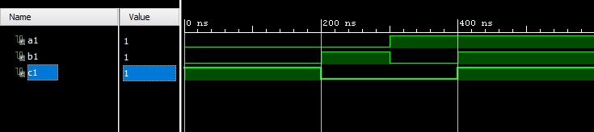

## HALF ADDER Dataflow Model

**VHD Code:**

entity HALF_ADDER_DF is

Port ( A : in STD_LOGIC; B : in STD_LOGIC;

S : out STD_LOGIC;

C : out STD_LOGIC); end HALF_ADDER_DF; architecture Dataflow of HALF_ADDER_DF is begin

S<=A xor B;

C<=A and B;

end Dataflow

### RTL Diagram

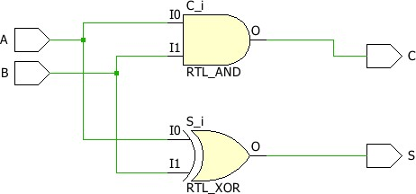

**TBW Code:**

entity HALF_ADDER_TBW is

-- Port ( );

end HALF_ADDER_TBW; architecture Behavioral of HALF_ADDER_TBW is component HALF_ADDER_BV is

Port ( A : in

STD_LOGIC; B: in

STD_LOGIC; S: out

STD_LOGIC;

C : out STD_LOGIC); end component;

Signal a1:STD_LOGIC:='0';

Signal b1:STD_LOGIC:='0';

Signal s1:STD_LOGIC; Signal c1:STD_LOGIC; begin

UUT: HALF_ADDER_BV Port map(A=>a1, B=>b1, S=>s1, C=>c1); stim_proc: process begin wait for 100ns; a1<='0'; b1<='0'; wait for 100ns; a1<='0'; b1<='1'; wait for 100ns; a1<='1'; b1<='0'; wait for 100ns; a1<='1'; b1<='1'; wait; end process; end Behavioral;

### TBW Waveform

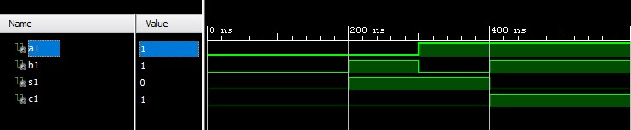

## HALF ADDER Behavioral Model

**VHD Code:**

entity HALF_ADDER_BV is

Port ( A : in STD_LOGIC;

B : in STD_LOGIC;

S : out STD_LOGIC;

C : out STD_LOGIC); end HALF_ADDER_BV; architecture Behavioral of HALF_ADDER_BV is begin process(A,B) begin if(A=B) then

S<='0'; else

S<='1'; end if; if(A='1' and B='1') then

C<='1'; else

C<='0'; end if; end process; end Behavioral;

**RTL Diagram:**



**TBW Code:**

entity HALF_ADDER_TBW is

-- Port ( );

end HALF_ADDER_TBW; architecture Behavioral of HALF_ADDER_TBW is component HALF_ADDER_BV is

Port ( A : in STD_LOGIC;

B: in STD_LOGIC;

S: out STD_LOGIC;

C : out STD_LOGIC); end component;

Signal a1:STD_LOGIC:='0'; Signal b1:STD_LOGIC:='0';

Signal s1:STD_LOGIC; Signal c1:STD_LOGIC; begin

UUT: HALF_ADDER_BV Port map(A=>a1, B=>b1, S=>s1, C=>c1); stim_proc: process begin wait for 100ns; a1<='0'; b1<='0'; wait for 100ns; a1<='0'; b1<='1'; wait for 100ns; a1<='1'; b1<='0'; wait for 100ns; a1<='1'; b1<='1'; wait; end process;

end Behavioral;

**TBW Waveform:**



**HALF ADDER Structural Model VHD Code:**

Entity HALF_ADDER_structural is

Port ( x : in STD_LOGIC; y : in STD_LOGIC; sum : out STD_LOGIC; carry : out STD_LOGIC); end HALF_ADDER_structural; architecture Structural of HALF_ADDER_structural is component XOR_DF is

Port ( A : in STD_LOGIC; B : in STD_LOGIC;

C : out STD_LOGIC); end component;

component AND_DF is

Port ( A : in STD_LOGIC; B : in STD_LOGIC;

C : out STD_LOGIC); end component; begin l1:XOR_DF port map(x,y,sum); l2:AND_DF port map(x,y,carry); end Structural;

### RTL Diagram

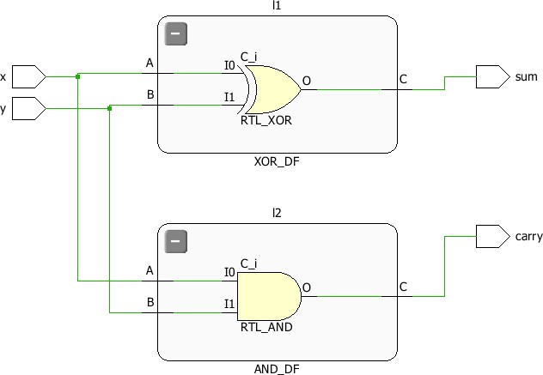

**TBW Code:**

entity HALF_ADDER_structural is Port ( x : in STD_LOGIC; y : in STD_LOGIC; sum : out STD_LOGIC; carry : out STD_LOGIC); end HALF_ADDER_structural; architecture Structural of HALF_ADDER_structural is

component XOR_DF is

Port ( A : in STD_LOGIC;

B : in STD_LOGIC; C : out STD_LOGIC); end component; component AND_DF is

Port ( A : in STD_LOGIC;

B : in STD_LOGIC; C : out STD_LOGIC); end component; begin l1:XOR_DF port map(x,y,sum); l2:AND_DF port map(x,y,carry); end Structural;

### TBW Waveform

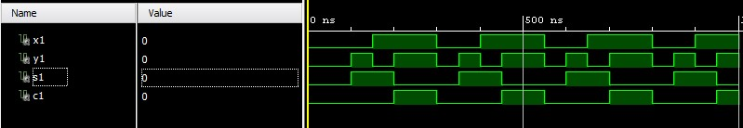

**FULL ADDER Dataflow Model VHD Code:**

entity FULL_ADDER_DF is

Port ( A : in STD_LOGIC;

B : in STD_LOGIC;

Cin : in STD_LOGIC;

S : out STD_LOGIC;

Cout : out STD_LOGIC); end FULL_ADDER_DF; architecture Behavioral of FULL_ADDER_DF is begin

S<=(A xor B) xor Cin;

Cout<=(A and B) or (B and Cin) or (Cin and A); end Behavioral;

### RTL Diagram

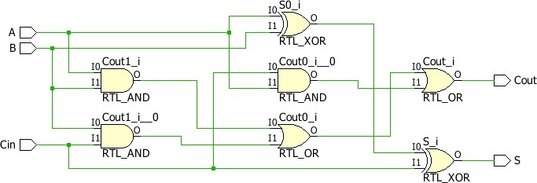

**TBW Code:**

entity FULL_ADDER_TBW is

-- Port ( );

end FULL_ADDER_TBW; architecture Behavioral of FULL_ADDER_TBW is component FULL_ADDER_BV is

Port ( A : in

AI Page Translation is now live! Click here

to set it up.

STD_LOGIC; B: in

STD_LOGIC; S: out

STD_LOGIC;

C : out STD_LOGIC); end component;

Signal a1:STD_LOGIC:='0'; Signal b1:STD_LOGIC:='0';

Signal s1:STD_LOGIC; Signal c1:STD_LOGIC; begin

UUT: FULL_ADDER_BV Port map(A=>a1, B=>b1, S=>s1, C=>c1); stim_proc: process begin wait for 100ns; a1<='0'; b1<='0'; wait for 100ns; a1<='0'; b1<='1'; wait for 100ns; a1<='1'; b1<='0'; wait for 100ns; a1<='1'; b1<='1'; wait; end process; end Behavioral;

### TBW Waveform

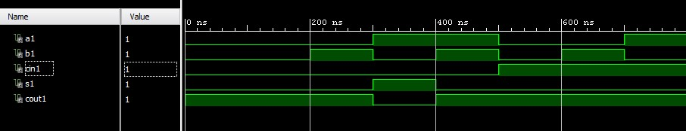

# FULL ADDER Behavioral Model

**VHD Code:**

entity FULL_ADDER_BV is

Port ( A : in STD_LOGIC;

B : in STD_LOGIC;

Cin: in STD_LOGIC;

S : out STD_LOGIC;

Cout : out STD_LOGIC); end FULL_ADDER_BV; architecture Behavioral of FULL_ADDER_BV is begin process(A,B,Cin) begin if((A='0') and (B=Cin)) then

S<='0'; else

S<='1'; end if; if((A='1') and (B=Cin)) then

S<='1'; else

S<='0'; end if; if((A='0') and (B='1' and Cin='1')) then

Cout<='1'; else

Cout<='0'; end if; if((A='1') and (B='0' and Cin='0')) then

Cout<='0'; else

Cout<='1'; end if; end process; end Behavioral;

## RTL Diagram

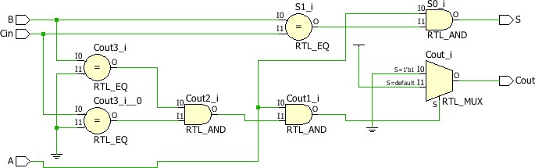

**TBW Code:**

entity FULL_ADDER_TBW is

-- Port ( );

end FULL_ADDER_TBW; architecture Behavioral of FULL_ADDER_TBW is component FULL_ADDER_BV is

Port ( A : in

STD_LOGIC; B: in

STD_LOGIC; S: out

STD_LOGIC;

C : out STD_LOGIC); end component;

Signal a1:STD_LOGIC:='0';

Signal b1:STD_LOGIC:='0';

Signal s1:STD_LOGIC; Signal c1:STD_LOGIC; begin

UUT: FULL_ADDER_BV Port map(A=>a1, B=>b1, S=>s1, C=>c1); stim_proc: process begin wait for 100ns; a1<='0'; b1<='0'; wait for 100ns; a1<='0'; b1<='1'; wait for 100ns; a1<='1'; b1<='0'; wait for 100ns; a1<='1'; b1<='1'; wait; end process; end Behavioral;

## TBW Waveform



# FULL ADDER Structural Model

**VHD Code:**

entity FULL_ADDER_structural is

Port ( x : in STD_LOGIC; y : in STD_LOGIC; z : in STD_LOGIC; sum : out STD_LOGIC; carry : out STD_LOGIC); end FULL_ADDER_structural; architecture Structural of FULL_ADDER_structural is component HALF_ADDER_DF is

Port ( A : in STD_LOGIC; B : in STD_LOGIC;

S : out STD_LOGIC;

C : out STD_LOGIC); end component; component OR_DF is

Port ( a : in STD_LOGIC; b : in STD_LOGIC; c : out STD_LOGIC); end component; signal s1:std_logic; signal c1:std_logic; signal c2:std_logic; begin l1:HALF_ADDER_DF port map(x,y,s1,c1); l2:HALF_ADDER_DF port map(s1,z,sum,c2); l3:OR_DF port map(c1,c2,carry);

end Structural;

## RTL Diagram

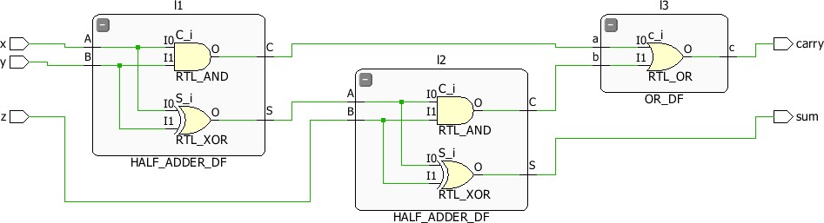

**TBW Code:**

entity FULL_ADDER_TBW is

-- Port ( );

end FULL_ADDER_TBW; architecture Structural of FULL_ADDER_TBW is component FULL_ADDER_structural is

Port ( x : in STD_LOGIC; y: in STD_LOGIC; z: in STD_LOGIC; sum: out STD_LOGIC; carry : out STD_LOGIC); end component;

Signal x1:STD_LOGIC:='0';

Signal y1:STD_LOGIC:='0';

Signal z1:STD_LOGIC:='0';

Signal s1:STD_LOGIC; Signal c1:STD_LOGIC; begin

UUT: FULL_ADDER_structural Port map(x=>x1, y=>y1, z=>z1, sum=>s1, carry=>c1); stim_proc: process begin wait for 50ns; x1<='0'; y1<='0'; z1<='1'; wait for 50ns; x1<='0'; y1<='1'; z1<='0'; wait for 50ns; x1<='0'; y1<='1'; z1<='1'; wait for 50ns; x1<='1'; y1<='0'; z1<='0'; wait for 50ns; x1<='1'; y1<='0'; z1<='1'; wait for 50ns; x1<='1'; y1<='1'; z1<='0'; wait for 50ns;

x1<='1'; y1<='1';

z1<='1'; wait for 50ns; end process; end Structural;

## TBW WaveForm

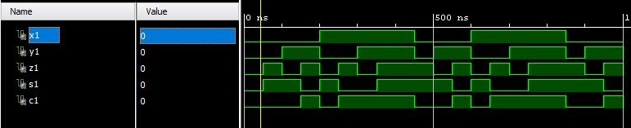

## 2:1 MUX Dataflow Model



VHD Code:



entity MUX_2_1_DF is

Port ( I0 : in STD_LOGIC;

I1 : in STD_LOGIC;

S : in STD_LOGIC; Y : out STD_LOGIC); end MUX_2_1_DF; architecture Dataflow of MUX_2_1_DF is begin

Y<=((NOT S) AND I0) OR (S AND I1); end Dataflow;

### RTL Diagram

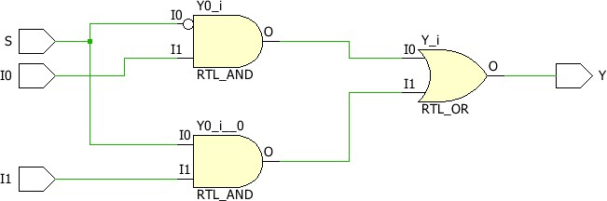

**TBW Code:**

entity MUX_2_1_TBW is

-- Port ( );

end MUX_2_1_TBW; architecture Dataflow of MUX_2_1_TBW is component MUX_2_1_BV is

Port ( I0 : in STD_LOGIC;

I1 : in STD_LOGIC;

S : in STD_LOGIC;

Y : out STD_LOGIC); end component; signal i01: STD_LOGIC:='0'; signal i11: STD_LOGIC:='0'; signal s1: STD_LOGIC:='0'; signal y1: STD_LOGIC; begin

UUT: MUX_2_1_DF Port map(I0=>i01, I1=>i11, S=>s1, Y=>y1);

stim_proc: process begin wait for 100ns; s1<='0'; wait for 100ns; s1<='1'; wait; end process; end Dataflow;

**TBW Waveform**

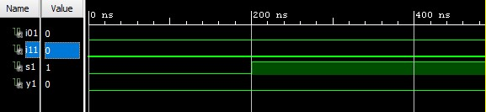

## 2:1 MUX Behavioral Model



VHD Code:



entity MUX_2_1_DF is

Port ( I0 : in STD_LOGIC;

I1 : in STD_LOGIC;

S : in STD_LOGIC; Y : out STD_LOGIC); end MUX_2_1_DF; architecture Behavioral of MUX_2_1_DF is begin process(I0,I1,S) begin if(S='0') then Y <= I0; else Y<= I1; end if;

end process; end Behavioral;



**RTL Diagram**



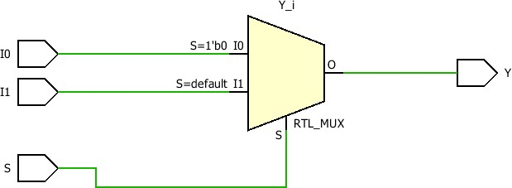

**TBW Code:**



entity MUX_2_1_TBW is

-- Port ( );

end MUX_2_1_TBW;

architecture Behavioral of MUX_2_1_TBW is component MUX_2_1_DF is

Port ( I0 : in STD_LOGIC;

I1: in STD_LOGIC;

S: in STD_LOGIC;

Y : out STD_LOGIC); end component;

Signal i01:STD_LOGIC:='0';

Signal i11:STD_LOGIC:='0';

Signal s1:STD_LOGIC:='0'; Signal y1:STD_LOGIC; begin

UUT: MUX_2_1_DF Port map(I0=>i01, I1=>i11, S=>s1, Y=>y1); stim_proc: process begin wait for 100ns; s1<='1'; wait; end process; end Behavioral;

### TBW Waveform

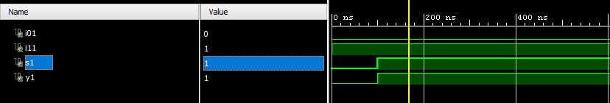

## 2:1 MUX Dataflow Model



**VHD Code:**



entity MUX_2_1_dataflow is

Port ( I0 : in STD_LOGIC;

I1 : in STD_LOGIC;

S : in STD_LOGIC;

Y : out STD_LOGIC); end MUX_2_1_dataflow; architecture Dataflow of MUX_2_1_dataflow is begin

Y <= (((not S) and I0) or (S and I1)); end Dataflow;

**RTL Diagram**





**TBW Code:**



entity MUX_2_1_TBW is

-- Port ( );

end MUX_2_1_TBW; architecture Behavioral of MUX_2_1_TBW is component MUX_2_1_DF is

Port ( I0 : in STD_LOGIC;

I1: in STD_LOGIC;

S: in STD_LOGIC;

Y : out STD_LOGIC); end component;

Signal i01:STD_LOGIC:='0';

Signal i11:STD_LOGIC:='0';

Signal s1:STD_LOGIC:='0'; Signal y1:STD_LOGIC; begin

UUT: MUX_2_1_DF Port map(I0=>i01, I1=>i11, S=>s1, Y=>y1); stim_proc: process begin wait for 100ns; s1<='1'; wait; end process; end Behavioral;

### TBW Waveform



## 4:1 MUX Dataflow Model



**VHD Code:**



entity MUX_4_1_DF is

Port ( IP : in STD_LOGIC_VECTOR (3 downto 0);

S : in STD_LOGIC_VECTOR (1 downto 0);

Y : out STD_LOGIC); end MUX_4_1_DF; architecture Dataflow of MUX_4_1_DF is begin

Y <= IP(0) when S="00" else

IP(1) when S="01" else

IP(2) when S="10" else

IP(3);

end Dataflow;

**RTL Diagram**



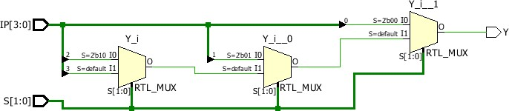

**TBW Code:**

entity MUX_4_1_TBW is

-- Port ( );

end MUX_4_1_TBW; architecture Behavioral of MUX_4_1_TBW is component MUX_4_1_BV is

Port ( IP : in STD_LOGIC_VECTOR (3 downto 0);

S : in STD_LOGIC_VECTOR (1 downto 0);

Y : out STD_LOGIC); end component;

Signal IP:STD_LOGIC_VECTOR(3 downto 0):="1010";

Signal S:STD_LOGIC_VECTOR(1 downto 0):="00"; Signal y1:STD_LOGIC; begin

UUT: MUX_4_1_BV Port map(IP=>IP, S=>S, Y=>y1); stim_proc: process begin

wait for 100ns; S(0)<='0'; S(1)<='1'; wait for 100ns; S(0)<='1'; S(1)<='0'; wait for 100ns; S(0)<='1'; S(1)<='1'; wait; end process; end Behavioral;

### TBW Waveform

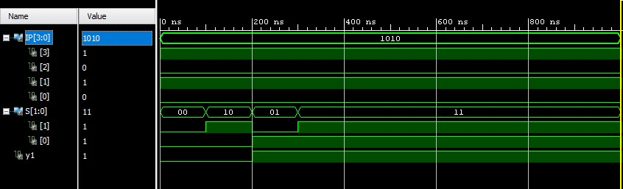



### 4:1 MUX Behavioral Model

**VHD Code:**

entity MUX_4_1_BV is

Port ( IP : in STD_LOGIC_VECTOR (3 downto 0);

S : in STD_LOGIC_VECTOR (1 downto 0);

Y : out STD_LOGIC); end MUX_4_1_BV; architecture Behavioral of MUX_4_1_BV is begin process(IP,S) begin case S is when "00" => Y <= IP(0); when "01" => Y <= IP(1); when "10" => Y <= IP(2); when "11" => Y <= IP(3);

when others => NULL; end case; end process; end Behavioral;



#### RTL Diagram

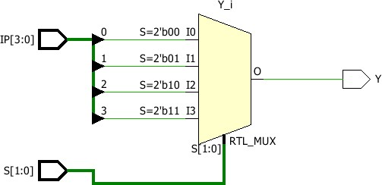

**TBW Code:**

entity MUX_4_1_TBW is

-- Port ( );

end MUX_4_1_TBW; architecture Behavioral of MUX_4_1_TBW is component MUX_4_1_BV is

Port ( IP : in STD_LOGIC_VECTOR (3 downto 0);

S : in STD_LOGIC_VECTOR (1 downto 0);

Y : out STD_LOGIC); end component;

Signal IP:STD_LOGIC_VECTOR(3 downto 0):="1010";

Signal S:STD_LOGIC_VECTOR(1 downto 0):="00"; Signal y1:STD_LOGIC; begin

UUT: MUX_4_1_BV Port map(IP=>IP, S=>S, Y=>y1); stim_proc: process begin wait for 100ns; S(0)<='0'; S(1)<='1'; wait for 100ns; S(0)<='1'; S(1)<='0'; wait for 100ns; S(0)<='1'; S(1)<='1'; wait; end process; end Behavioral;

#### TBW Waveform



### 3:8 Decoder Dataflow Model

**VHD Code:**

entity DECODER_3_8_DF is

Port ( IP : in STD_LOGIC_VECTOR (2 downto 0); OP : out STD_LOGIC_VECTOR (7 downto 0)); end DECODER_3_8_DF;

architecture Dataflow of DECODER_3_8_DF is

begin

OP(0) <='1' when IP = "000" else '0';

OP(1) <='1' when IP = "001" else '0';

OP(2) <='1' when IP = "010" else '0';

OP(3) <='1' when IP = "011" else '0';

OP(4) <='1' when IP = "100" else '0';

OP(5) <='1' when IP = "101" else '0';

OP(6) <='1' when IP = "110" else '0'; OP(7) <='1' when IP = "111" else '0';

end Dataflow;

**RTL Diagram**

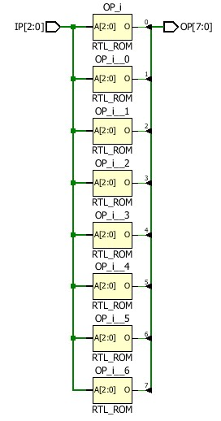

**TBW Code:**

entity DECODER_3_8_TBW is

-- Port ( );

end DECODER_3_8_TBW; architecture Dataflow of DECODER_3_8_TBW is component DECODER_3_8_DF is

Port ( IP : in STD_LOGIC_VECTOR (2 downto 0); OP : out STD_LOGIC_VECTOR (7 downto 0)); end component;

Signal IP:STD_LOGIC_VECTOR(2 downto 0):="000"; Signal OP:STD_LOGIC_VECTOR(7 downto 0); begin

UUT: DECODER_3_8_DF Port map(IP=>IP, OP=>OP); stim_proc: process begin wait for 100ns; IP(0)<='0';

IP(1)<='0'; IP(2)<='1'; wait for 100ns; IP(0)<='0';

IP(1)<='1'; IP(2)<='0'; wait for 100ns; IP(0)<='0';

IP(1)<='1'; IP(2)<='1'; wait for 100ns; IP(0)<='1'; IP(1)<='0'; IP(2)<='0'; wait for 100ns; IP(0)<='1';

IP(1)<='0'; IP(2)<='1'; wait for 100ns; IP(0)<='1';

IP(1)<='1'; IP(2)<='0'; wait for 100ns; IP(0)<='1';

IP(1)<='1'; IP(2)<='1'; wait; end process; end Dataflow;

**TBW Waveform**

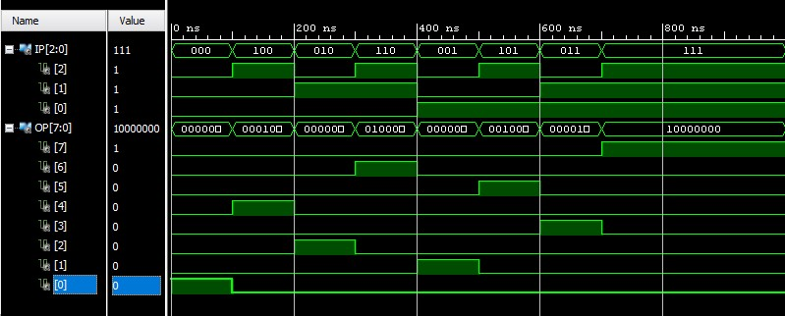

# 3:8 Decoder Behavioral Model

**VHD Code:**

entity Decoder_3_8_BV is

Port ( IP : in STD_LOGIC_VECTOR (2 downto 0);

OP : out STD_LOGIC_VECTOR (7 downto 0));

end Decoder_3_8_BV;

architecture Behavioral of Decoder_3_8_BV is begin process(IP) begin

OP<="00000000";

case IP is when "000" => OP(0) <= '1'; when "001" => OP(1) <= '1'; when "010" => OP(2) <= '1'; when "011" => OP(3) <= '1'; when "100" => OP(4) <= '1'; when "101" => OP(5) <= '1'; when "110" => OP(6) <= '1'; when "111" => OP(7) <= '1'; when others => NULL; end case; end process; end Behavioral;

## RTL Diagram

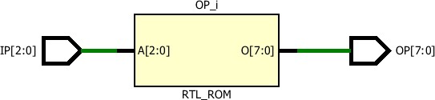

**TBW Code:**

entity DECODER_3_8_TBW is

-- Port ( );

end DECODER_3_8_TBW; architecture Dataflow of DECODER_3_8_TBW is component DECODER_3_8_DF is

Port ( IP : in STD_LOGIC_VECTOR (2 downto 0);

OP : out STD_LOGIC_VECTOR (7 downto 0)); end component;

Signal IP:STD_LOGIC_VECTOR(2 downto 0):="000"; Signal OP:STD_LOGIC_VECTOR(7 downto 0); begin

UUT: DECODER_3_8_DF Port map(IP=>IP, OP=>OP); stim_proc: process begin wait for 100ns; IP(0)<='0';

IP(1)<='0'; IP(2)<='1'; wait for 100ns; IP(0)<='0';

IP(1)<='1'; IP(2)<='0'; wait for 100ns; IP(0)<='0';

IP(1)<='1';

IP(2)<='1';

wait for 100ns; IP(0)<='1';

IP(1)<='0'; IP(2)<='0'; wait for 100ns; IP(0)<='1';

IP(1)<='0'; IP(2)<='1'; wait for 100ns; IP(0)<='1';

IP(1)<='1'; IP(2)<='0'; wait for 100ns; IP(0)<='1';

IP(1)<='1'; IP(2)<='1'; wait; end process; end Dataflow;

## TBW Waveform

